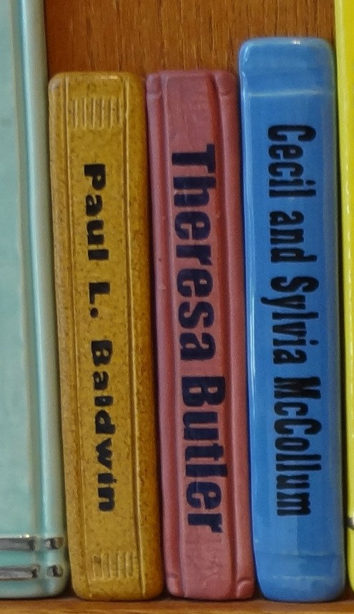
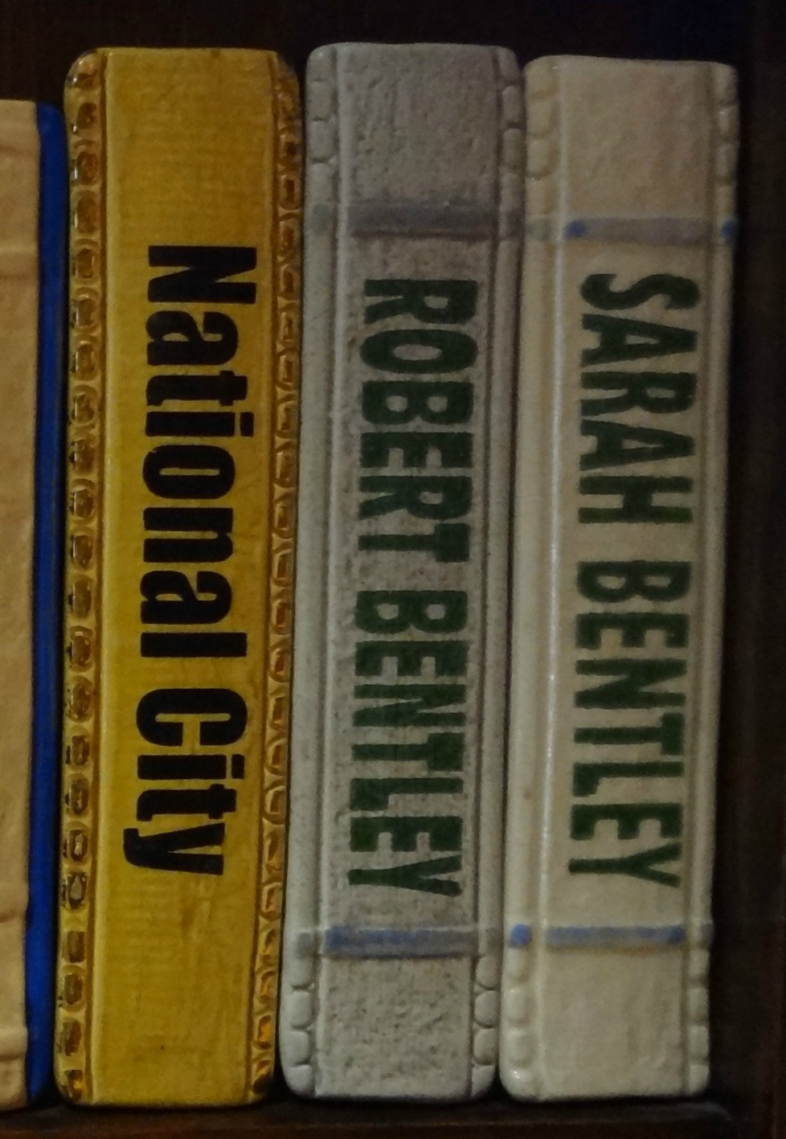
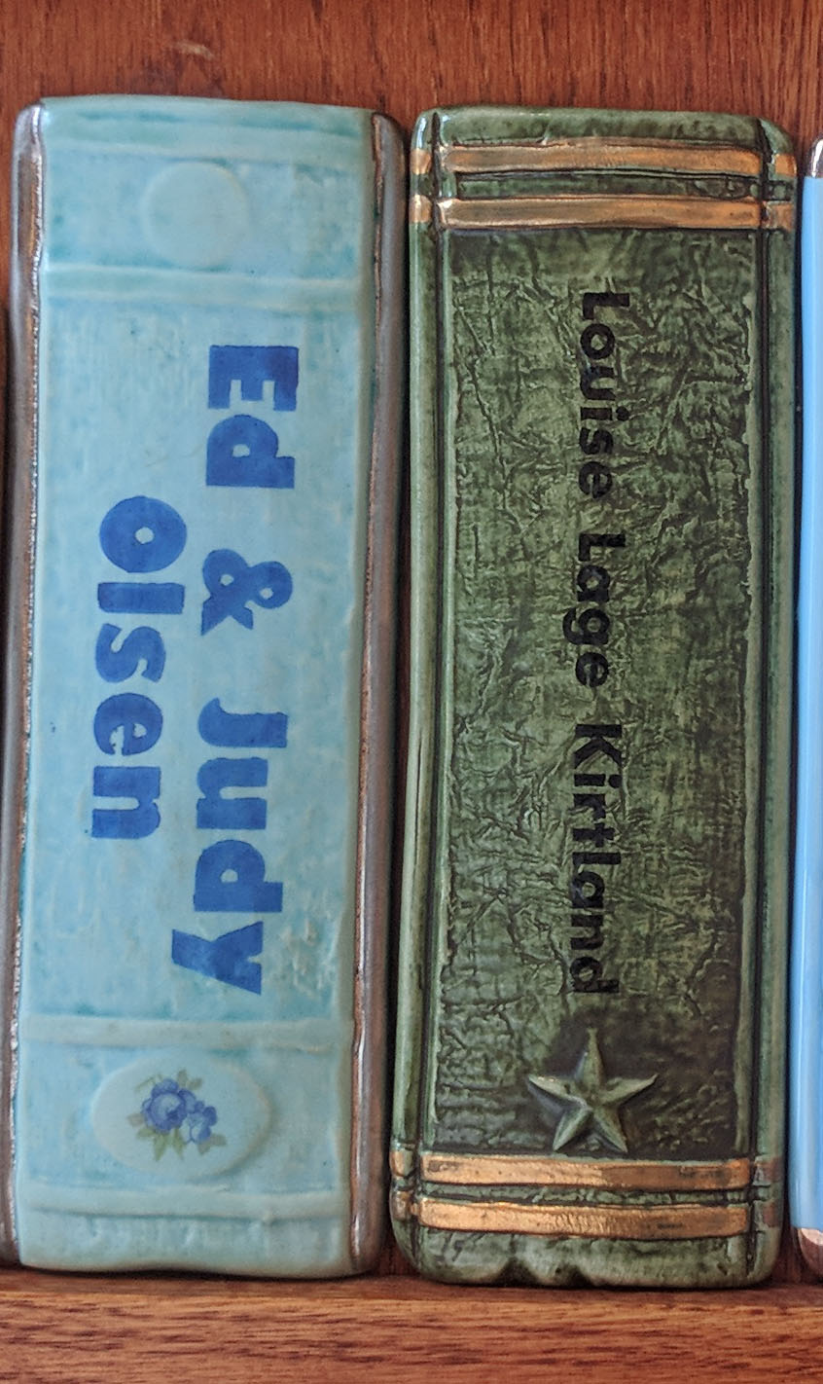

1” Tile | 2” Tile | 3” Tile
1 line | Up to 2 lines | Up to 2 lines
❑ $50 one-time payment | ❑ $100 one-time payment | ❑ $250 one-time payment
❑  $10/month for 5 months* | ❑ $20/month for 5 months* | ❑ $50/month for 5 months*
*Monthly payments are only available to donors paying online.
It is up to you to cancel future payments. Tiles will be ordered after they are paid for in full.
Name:___________________________________________________________________________________
Address:_________________________________________________________________________________
City, State, Zip:___________________________________________________________________________
Phone:____________________________________Email:____________________________________
Please indicate below the inscription you would like on your tile. The artist cannot match or guarantee specific colors. Space is limited to approximately 17 characters per line.
____________________________________________________________________________________________________________________________________________________________________________________
Book tiles will be installed and available to view when the new building opens.

Payment Method
❑ Check (Please make check payable to: IndyPL Foundation)
❑ Credit card (Card will be charged upon receipt; monthly payments must be made online)
Card number:
Expiration Date: CVV:
Signature:
❑ Online (You will give the payment(s) marked above online at indyplfoundation.org/give)
❑ Cash (For office use only. Date and amount entered into Horizon: )

