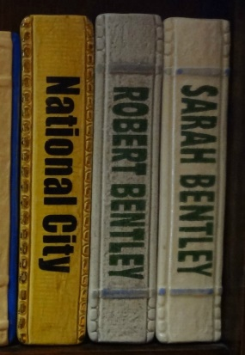
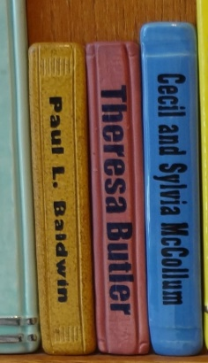

1” Tile | 2” Tile | 3” Tile
1 line | Up to 2 lines | Up to 2 lines
$50 one-time payment | $100 one-time payment | $250 one-time payment
$10/month for 5 months* | $20/month for 5 months* | $50/month for 5 months*
*Monthly payments are only available to donors paying online.
It is up to you to cancel future payments. Tiles will be ordered once paid in full.
Name:___________________________________________________________________________________
Address:_________________________________________________________________________________
City, State, Zip:___________________________________________________________________________
Phone:____________________________________Email:____________________________________
Please indicate below the inscription you would like on your tile. The artist cannot match or guarantee specific colors. Space is limited. For best results, inscriptions should be approximately 15 characters per line, including spaces.
__________________________________________________________________________________________

__________________________________________________________________________________________
After the sale ends, please allow up to ten weeks for custom tile creation and installation.

Payment Method
Check (Please make check payable to: IndyPL Foundation)
Online/Credit Card (You will give the payment(s) marked above online at indyplfoundation.org/give or by calling 317-275-4700)
Cash (For office use only. Date and amount entered into Polaris: )

